**INTRODUCTION TO AUTOMATION ANYWHERE**

**What is automation anywhere?**

It is an RPA tool whose motive is to provide users scalable,secure and resilent services.

The tool offers that,

* 30day free trial
* Integrates with different platform
* Visual designer
* Scales simultaneously

**ARCHITETURE OF AUTOMATION ANYWHERE**

Automation anywhere has mainly three component in the architecture.

* **Bot creators**
* **Control room**
* **Bot runners**

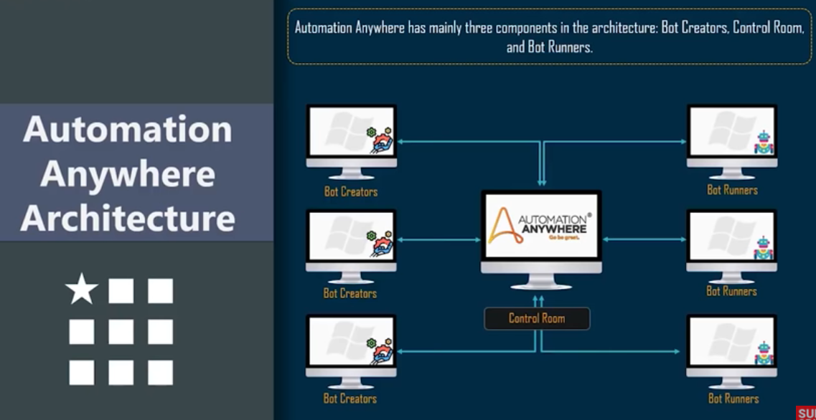

**Bot creators:** Bot creators are used to create bots.these are desktop based application which authenticate against an active control room and only have access to upload or download bots.

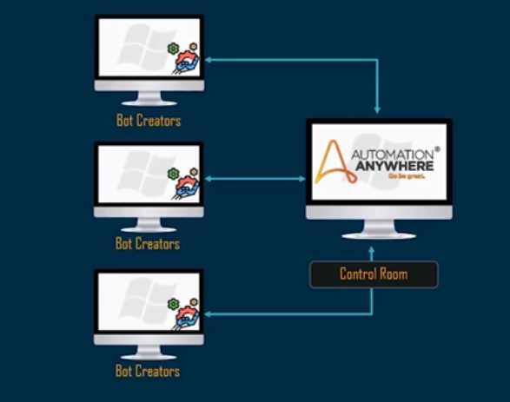

**Control room**

Control room is the most important component of the architecture.it is a web server that basically control the bots create by the bot creators.

The features are,

* Centralised user management
* Automation deployment
* Provides dashboard
* Source control

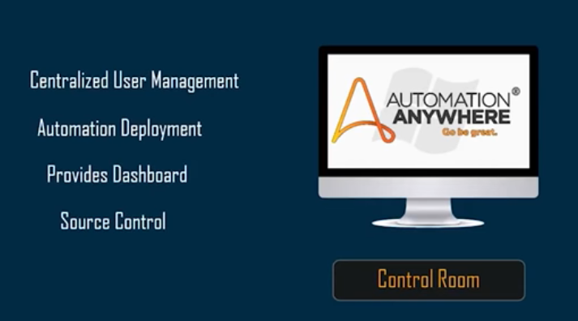

**Bot runners:** Bot runners are used to execute the bots. multiple bots can be executed in parallel and cannot update or create automation.

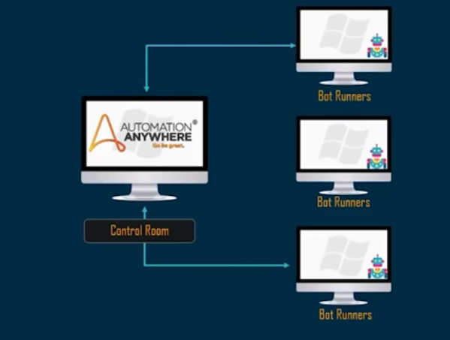

**PRODUCTS OF AUTOMATION ANYWHERE**

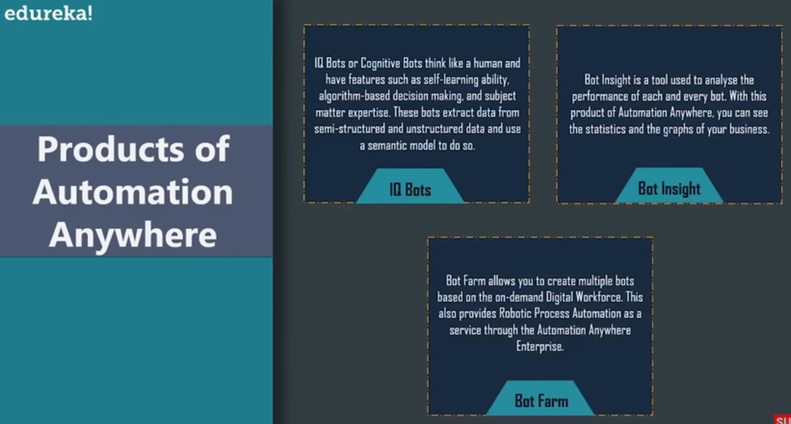

**INSTALLATION OF AUTOMATION ANYWHERE**

* Go to google and search

**www.automation anywhere.com/in/lp/free-trail**

* Click free trail and fill the details and click start trail.
* Check your mail and proceed. first login the **IQ Bots** then login the **Enterprise RPA**

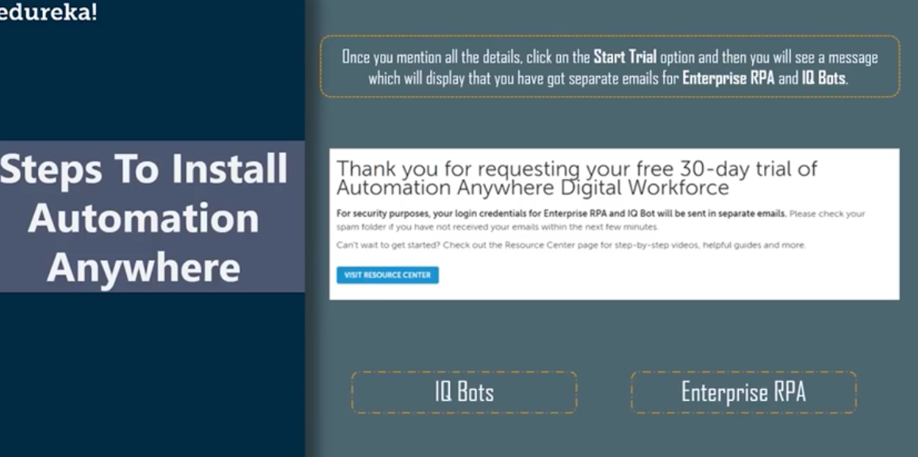

**INDUSTRIES USING AUTOMATION ANYWHERE**

**I**t is using many fields to done in this industry.

* Business process outsourcing
* Healthcare industry
* Telecom industry
* Financial services
* Manufacturing